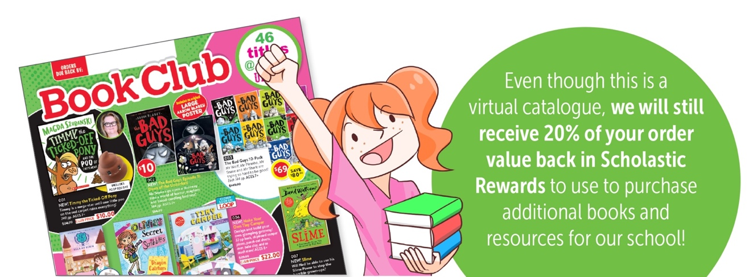

We’re really excited to have **BOOK CLUB** running this Term, but it will look a little different! It will be a **virtual catalogue** rather than the printed catalogues you’re used to receiving.

**To order from this issue go to:**

*Scholastic.com.au/Book-Club/virtual-catalogue-1/*

**Place your order on the LOOP app. Orders need to be in by 8th May 2020**

**We will receive your order here to our school like normal. Once your order arrives, we will contact you to arrange for collection.**

**If you have any questions or queries, please contact the school office on 5782 1319.**